Project Two README
About the Project
This project builds on the Python module called CRUD_Python_Module.py, which provides Create, Read, Update, and Delete functionality for an animal shelter database. The module connects to the aac database and animals collection in MongoDB using PyMongo. The Create function uses insert_one() to add new animal records, the Read function uses find() to search for animal records using a query, the Update function uses update_many() with the $set operator to modify existing records, and the Delete function uses delete_many() to remove matching records. The module uses the AnimalShelter class so the database functions can be reused by other Python programs without having to write the database connection and operations again.
The broader purpose of this project is to provide Grazioso Salvare with a way to use animal shelter records to identify dogs that may be suitable for search-and-rescue training. The organization trains dogs to find and help rescue people or other animals in life-threatening situations. Since different breeds are suited for different types of rescue work, the animal data can help identify dogs based on their breed, sex, and age. The Python module provides the database functionality needed to access and manage these records, while the dashboard developed for Project Two gives users an interactive way to filter the data by water rescue, mountain or wilderness rescue, and disaster rescue or individual tracking. The dashboard displays the matching records in a data table, shows the selected animal's location on a map, and uses a pie chart to summarize the displayed data.
Motivation
The motivation for this project is to build on the reusable Python module developed in Project One and make it easier to work with the AAC animal shelter database. The module keeps the MongoDB connection and Create, Read, Update, and Delete operations in one place, which helps avoid repeating the same database code when working with animal records. Each operation also includes exception handling to help handle errors when working with the database.
The module provides the database functionality needed for the Grazioso Salvare project. For Project Two, the module is used by an interactive dashboard that allows users to filter animal shelter records based on different types of search-and-rescue training. The dashboard displays the matching records in a data table, shows the selected animal's location on a map, and uses a pie chart to summarize the data. This makes it easier for users to review animal records and identify dogs that may meet the requirements for different types of rescue work.
Getting Started
To reproduce this project, MongoDB needs to be set up with the aac database and the animal shelter dataset in the animals collection. The animal shelter CSV file is imported into MongoDB using the mongoimport command. Authentication is enabled, and the aacuser account is created with read and write access to the aac database. The CRUD_Python_Module.py file contains the AnimalShelter class and the Create, Read, Update, and Delete methods. The ProjectTwoDashboard.ipynb Jupyter Notebook imports the AnimalShelter class and uses it to retrieve animal records for the dashboard. The Python module uses PyMongo to connect to MongoDB and perform the database operations.
To run the project, first start MongoDB and make sure the animal shelter dataset is available in the animals collection. Verify that the database authentication and connection settings in CRUD_Python_Module.py are correct. Next, open ProjectTwoDashboard.ipynb in Jupyter Notebook and run the cells in order to import the required libraries, connect to the database, load the animal records, and launch the dashboard. Use the filter options to view records for water rescue, mountain or wilderness rescue, and disaster rescue or individual tracking. The Reset option returns the dashboard to the unfiltered records. The data table, map, and pie chart update based on the selected filter and animal record.
The project uses a class-based structure for the database operations, which provides the model portion of an MVC application. The dashboard provides the interface for users to filter and visualize the animal records, while the CRUD module handles the database connection and operations separately. While completing the project, I worked through issues with the dashboard components and their callbacks to make sure the filters, data table, map, and pie chart responded to user selections.
Installation
All tools and libraries used for this project were already included in the Codio environment, so no manual installation was required. The following tools and libraries were used for this project.
- MongoDB: MongoDB was used to store the aac database and the animals collection. The Python module connects to MongoDB to retrieve animal records for the dashboard.
- Python 3: Python was used to develop and run the CRUD module and the dashboard notebook. Codio includes Python 3.
- PyMongo: PyMongo is the Python library used to connect to MongoDB. The module uses functions such as insert_one(), find(), update_many(), and delete_many() to perform the CRUD operations.
- Jupyter Notebook: Jupyter Notebook was used to develop and run the dashboard application and its Python code.
- Dash: Dash was used to create the interactive dashboard and connect the filtering options to the displayed data.
- JupyterDash: JupyterDash was used to run the Dash application in the Jupyter Notebook environment.
- Dash Leaflet: Dash Leaflet was used to display the geographic map and the selected animal's location.
- Plotly Express: Plotly Express was used to create the pie chart that summarizes the animal records.
- Pandas: Pandas was used to organize the animal records into a DataFrame for display in the data table and use in the dashboard callbacks.
Usage
This project uses the AnimalShelter class from CRUD_Python_Module.py to connect to the aac MongoDB database and retrieve animal records from the animals collection. The module provides Create, Read, Update, and Delete operations, while the dashboard uses the database records to display information for Grazioso Salvare.
The dashboard is run through the ProjectTwoDashboard.ipynb Jupyter Notebook. Users can select Water Rescue, Mountain or Wilderness Rescue, Disaster or Individual Tracking, or Reset to filter the animal records. The data table updates to display the matching records, the map shows the location of the selected animal, and the pie chart summarizes the displayed data. Selecting Reset returns the dashboard to the unfiltered records.
Code Example:
The following code shows the main Create, Read, Update, and Delete methods from CRUD_Python_Module.py. These methods use PyMongo to perform database operations on the animals collection in MongoDB. Each method includes exception handling and checks for the required input before performing an operation.

def create(self, data):
try:
if data is not None:
self.collection.insert_one(data)
return True
else:
return False
except Exception as e:
print(f"Create error: {e}")
return False

def read(self, query):
try:
if query is not None:
results = list(self.collection.find(query))
return results
else:
return []
except Exception as e:
print(f"Read error: {e}")
return []

def update(self, query, update_data):
try:
if query is not None and update_data is not None:
results = self.collection.update_many(query, update_data)
return results.modified_count
else:
return 0
except Exception as e:
print(f"Update error: {e}")
return 0

def delete(self, query):
try:
if query is not None:
results = self.collection.delete_many(query)
return results.deleted_count
else:
return 0
except Exception as e:
print(f"Delete error: {e}")
return 0

Tests
The Create, Read, Update, and Delete functions were tested in the ProjectOneTestScript.ipynb Jupyter Notebook. I imported the AnimalShelter class, created an instance of the class, and used a test animal record to run each CRUD operation. The Create function added the test record, the Read function retrieved the record, the Update function changed the breed, and the Delete function removed the test record.
The test produced a True result for Create, the test record was returned by Read, and both Update and Delete returned 1, showing that one document was modified and one document was removed. I also ran a final Read operation for TEST001, which returned an empty list to verify that the test record was deleted.
The dashboard was tested in the Project Two Jupyter Notebook to verify that the filter options and dashboard components worked as expected. I tested the Water Rescue, Mountain or Wilderness Rescue, and Disaster or Individual Tracking filters, along with the Reset option. I checked that the data table updated to display the matching records, the map displayed the selected animal's location, and the pie chart updated to summarize the displayed data. I also tested Reset to confirm that the dashboard returned to the unfiltered records.
# Python Testing Script
# Imports the CRUD module
from CRUD_Python_Module import AnimalShelter
# Creates an instance of the AnimalShelter class
shelter = AnimalShelter()
# Creates a test animal record
test_animal = {
"animal_id": "TEST001",
"animal_type": "Dog",
"breed": "Test Breed"
}
print(shelter.create(test_animal))
# Reads the test animal record
results = shelter.read({"animal_id": "TEST001"})
print(results)
# Updates the test animal record
print(shelter.update(
{"animal_id": "TEST001"},
{"$set": {"breed": "Updated Test Breed"}}
))
# Deletes the test animal record
print(shelter.delete({"animal_id": "TEST001"}))
True
[{'_id': ObjectId('6ac29a28055cd139c9b01b55'), 'animal_id': 'TEST001', 'animal_type': 'Dog', 'breed': 'Test Breed'}]
1
1
shelter.read({"animal_id": "TEST001"})
[]
Screenshots
Import and Execution
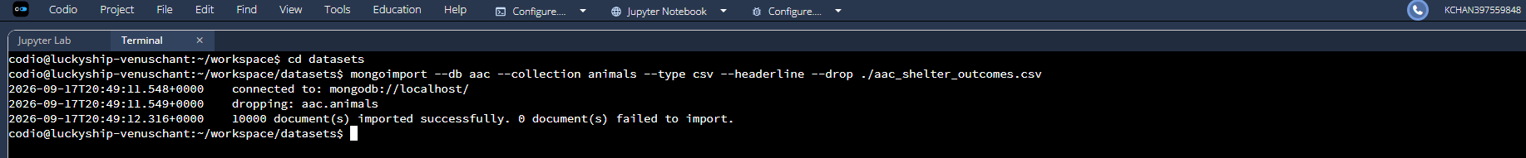
Simple Index and Explain Function
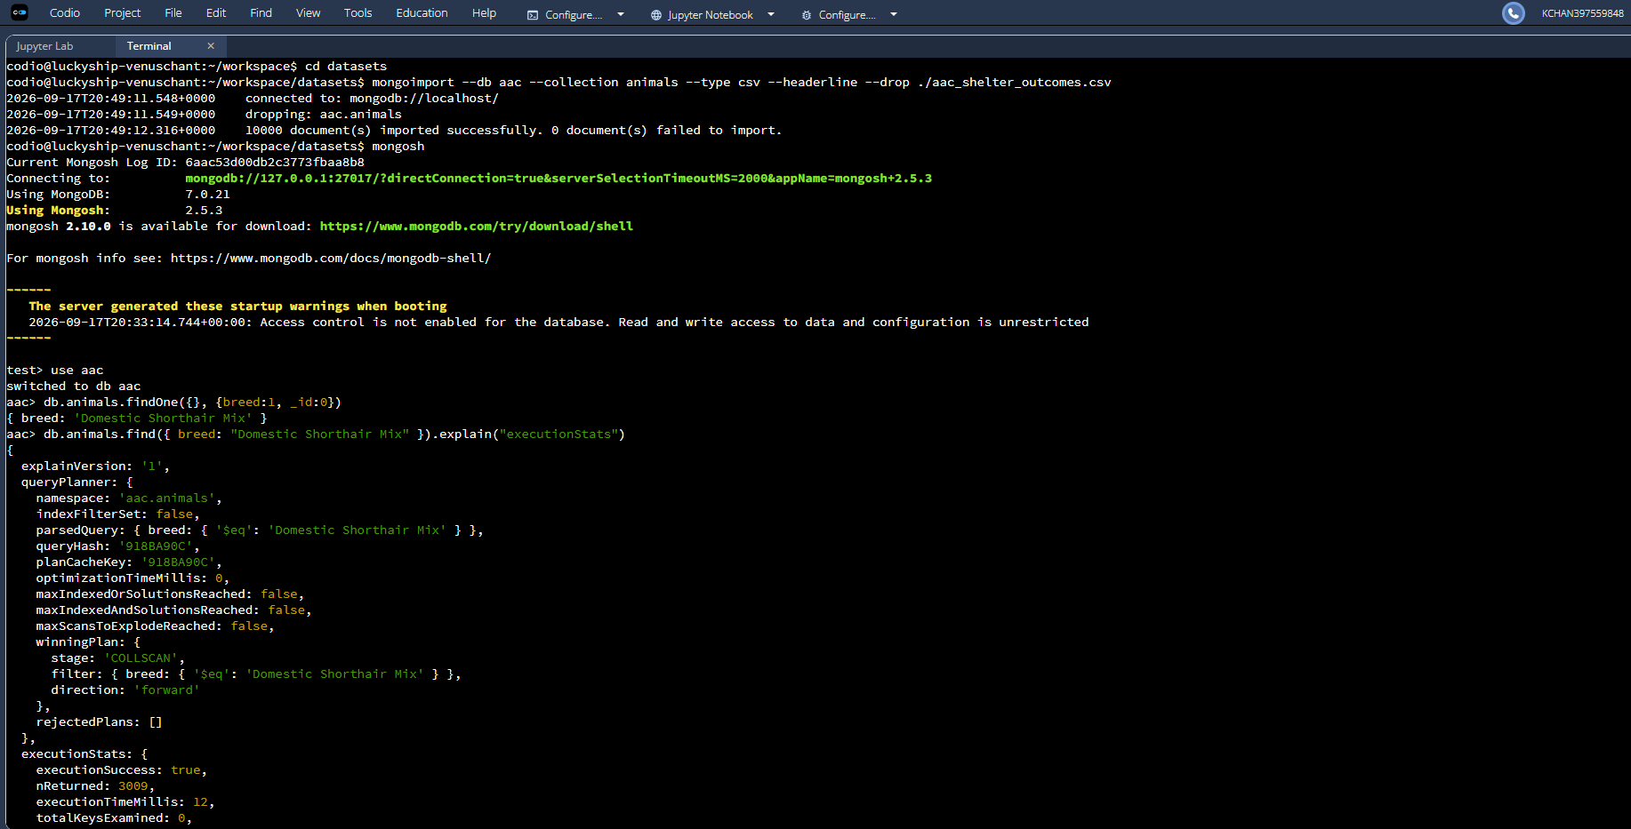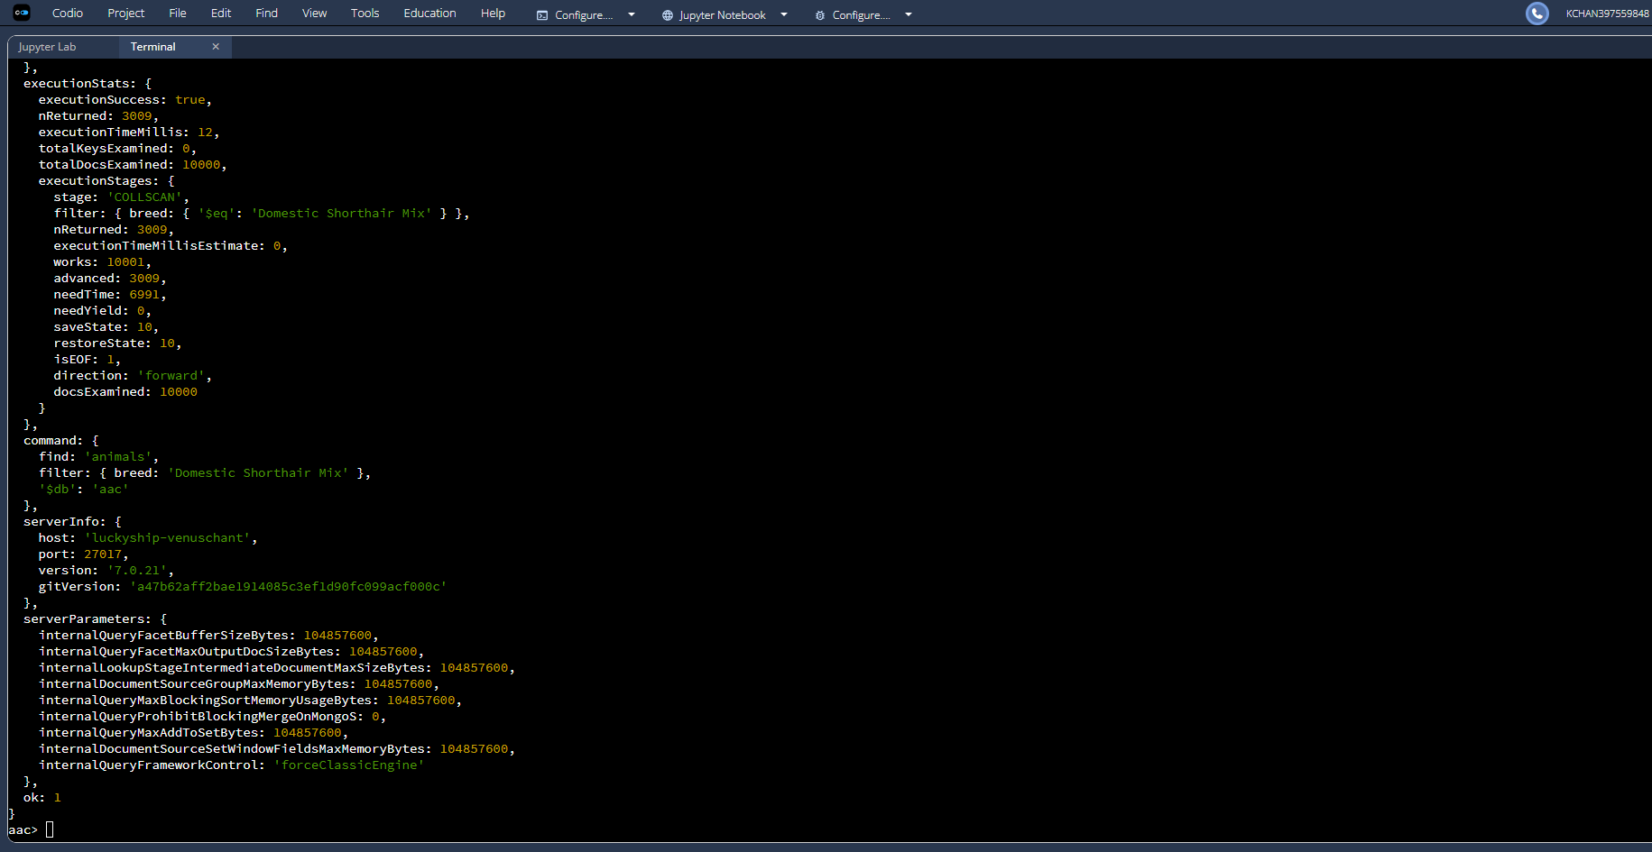
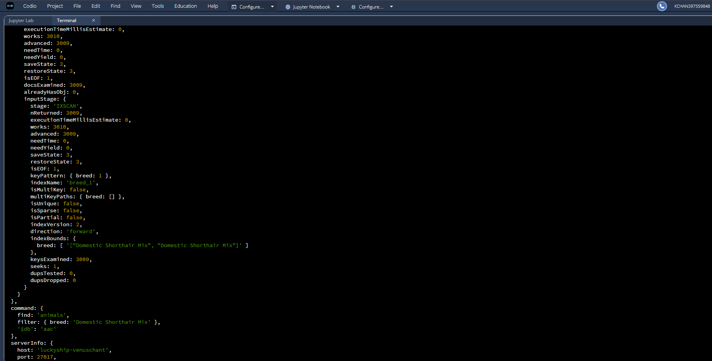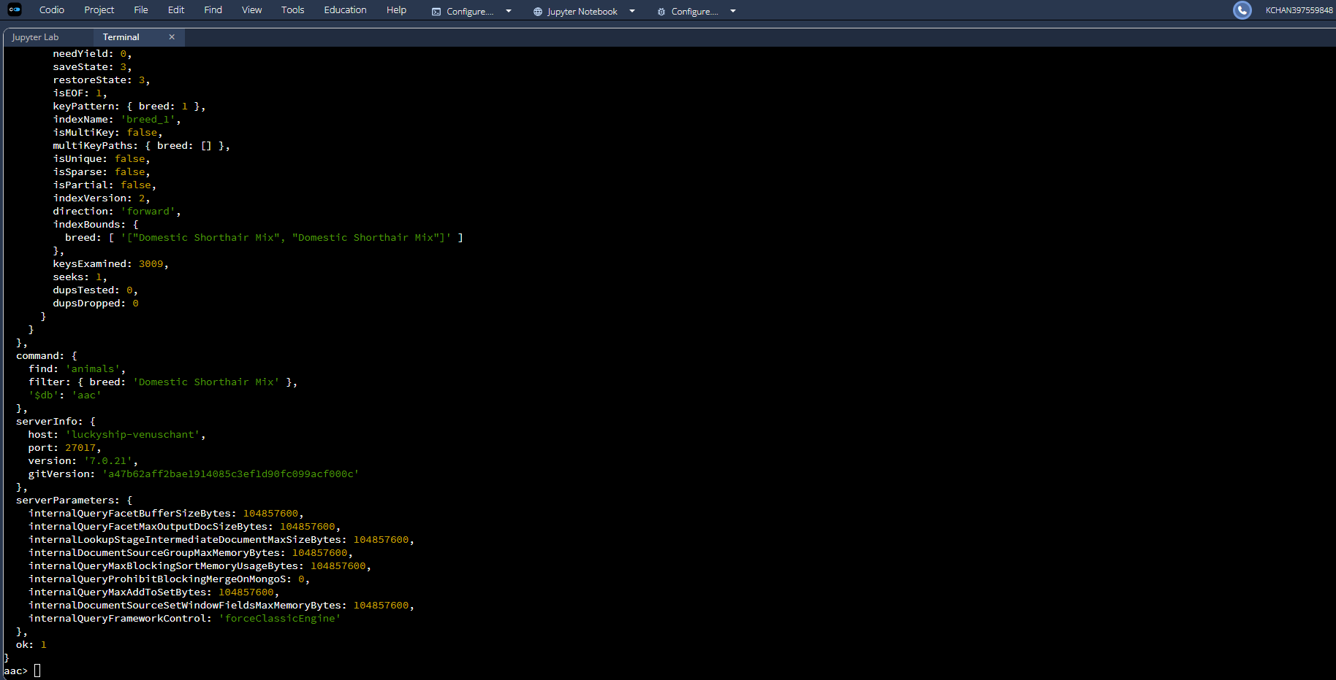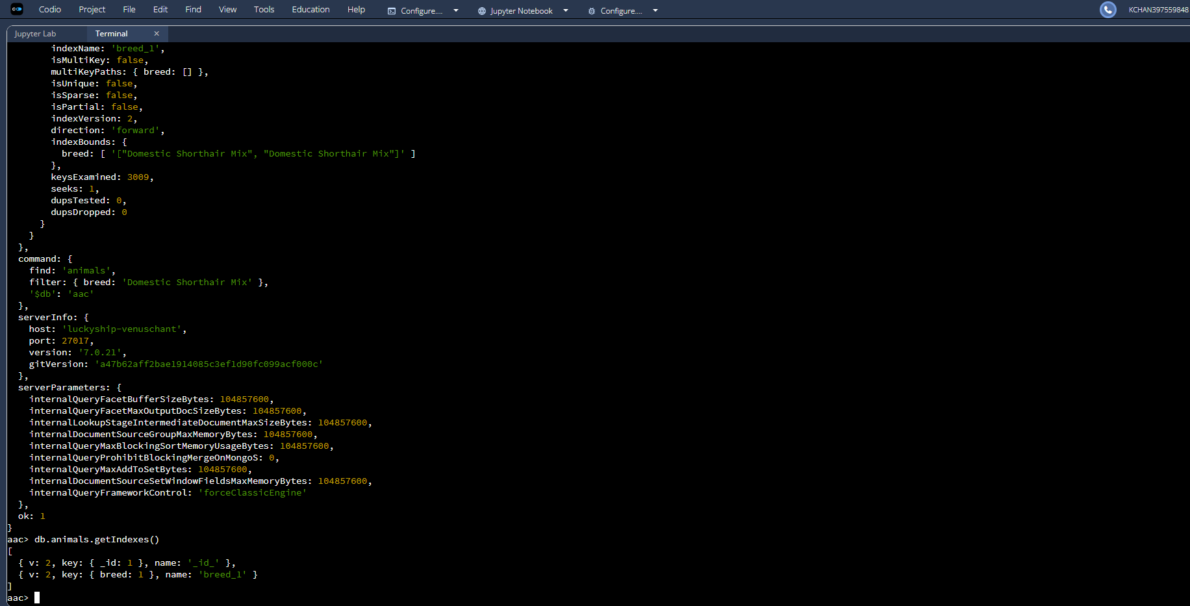
Compound Index and Explain Function
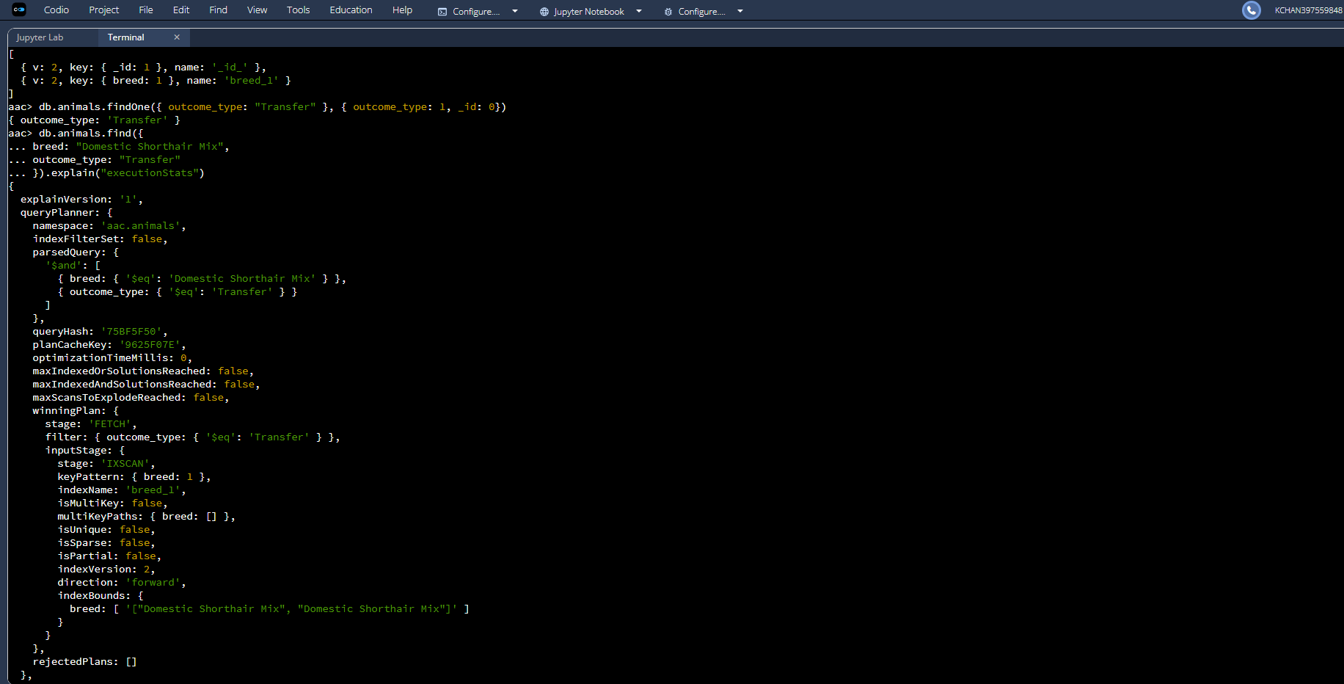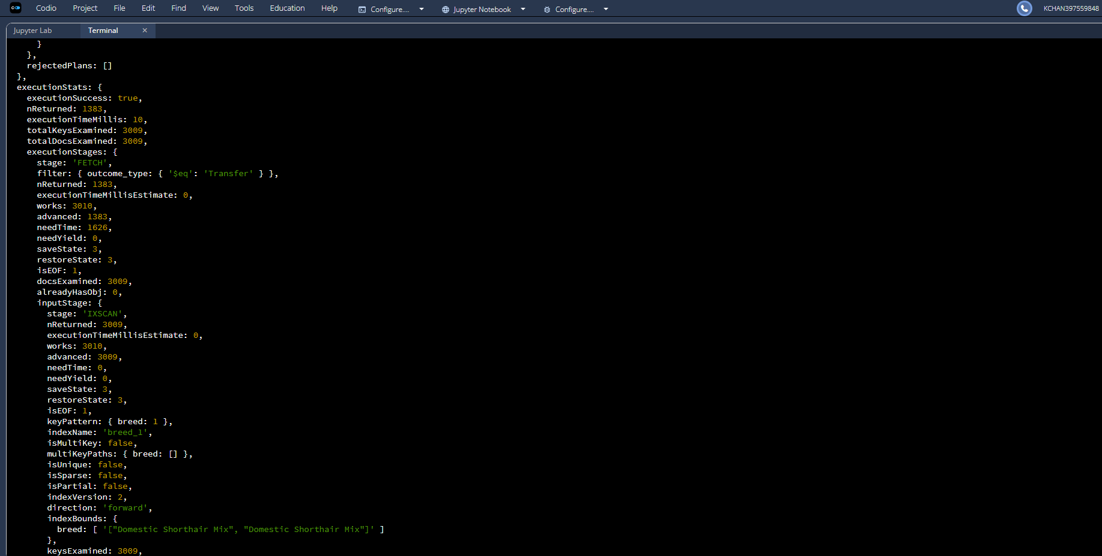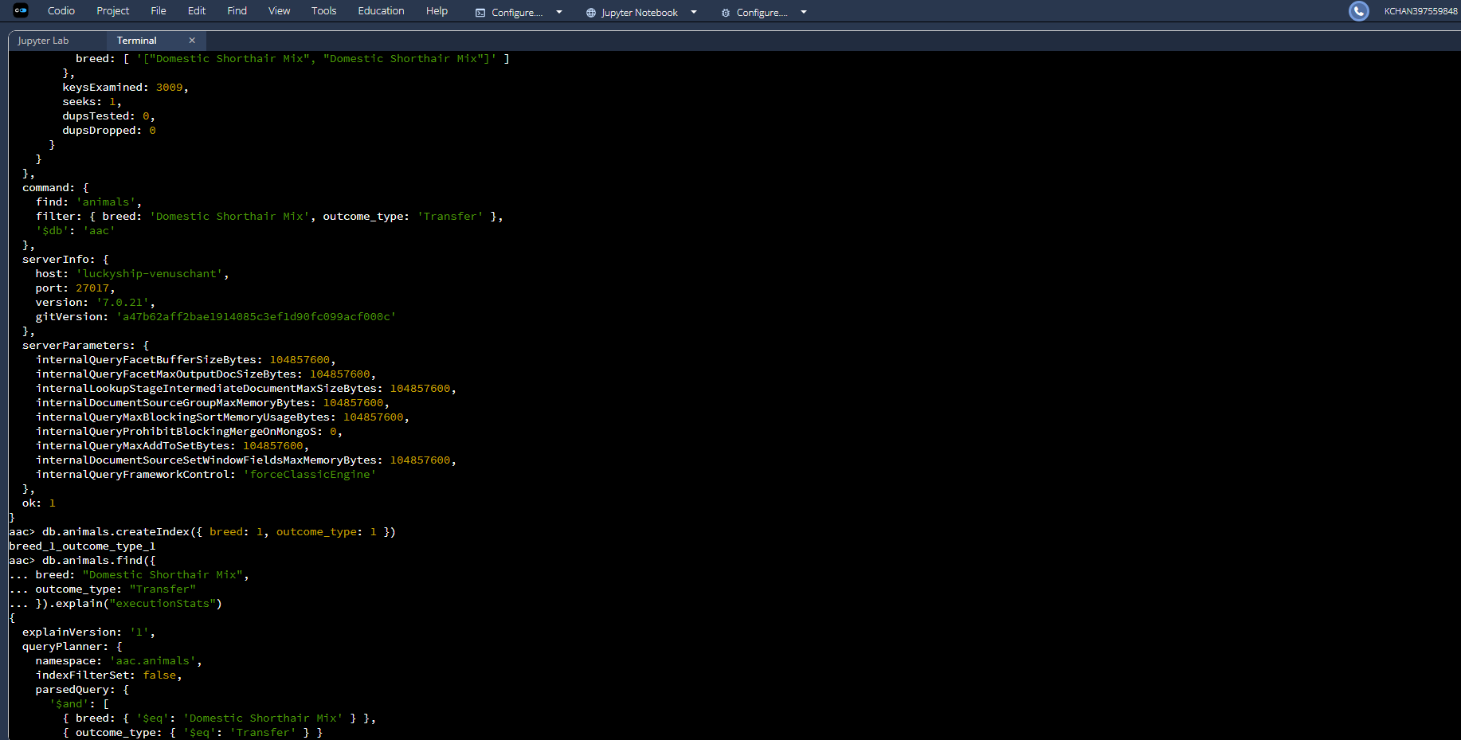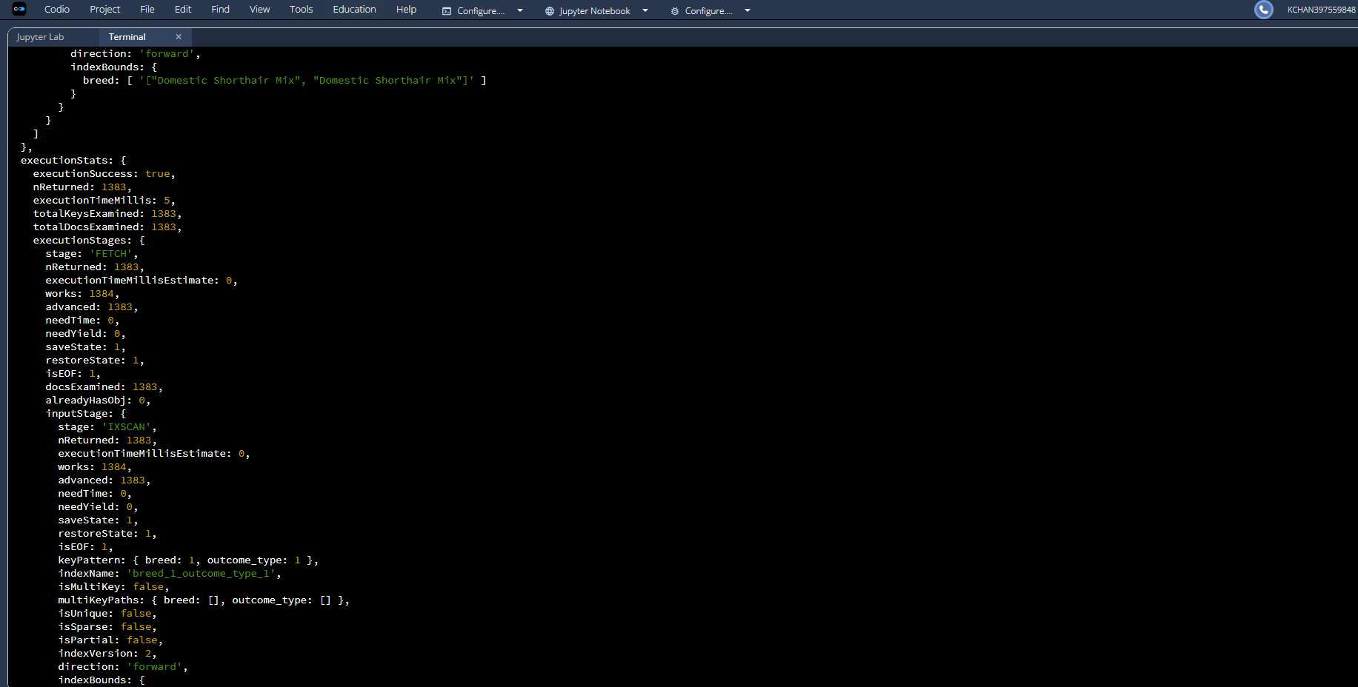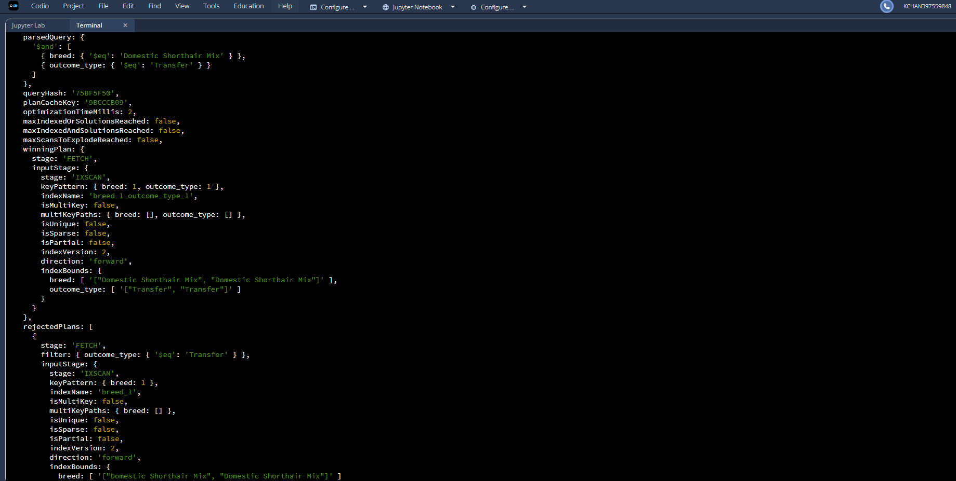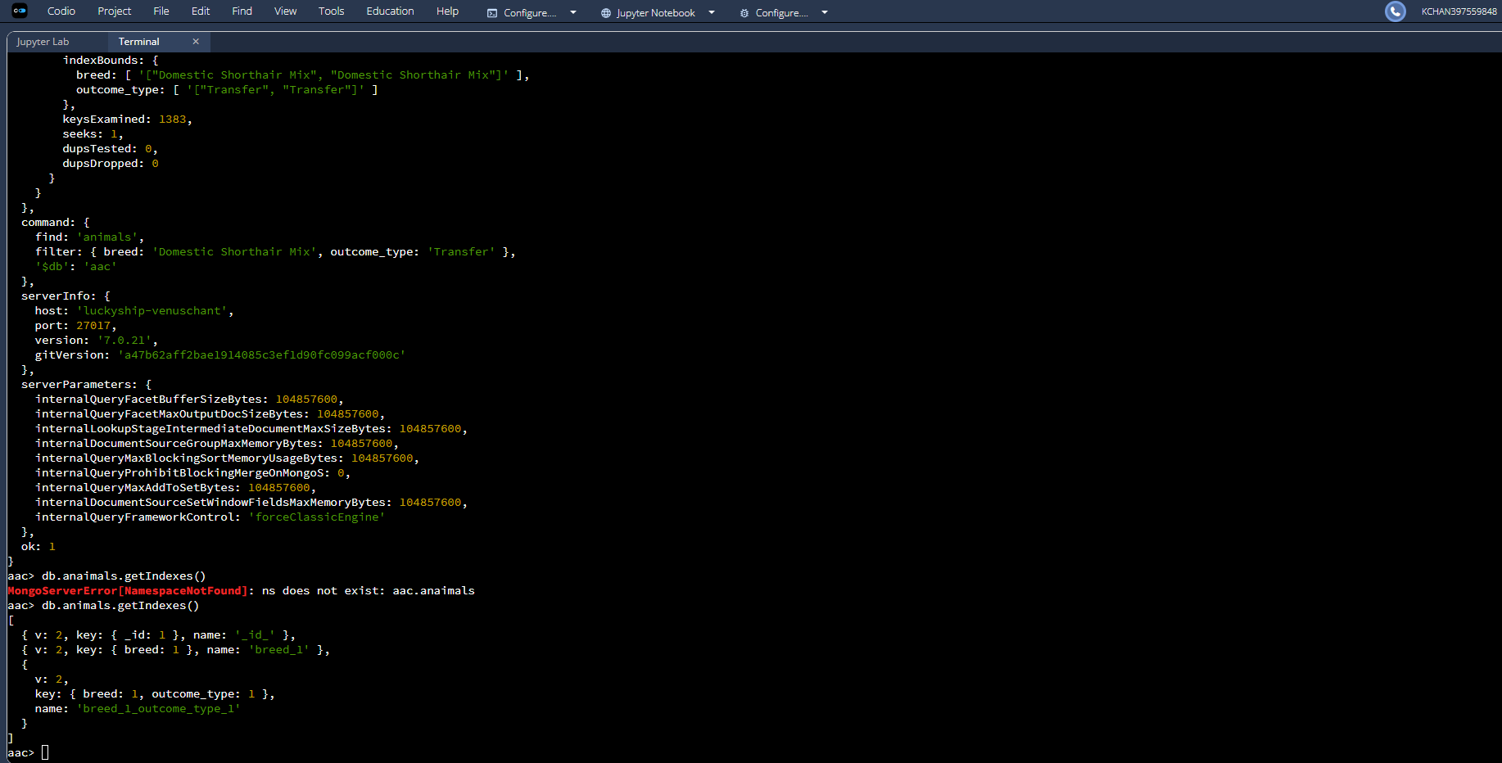

Ensure User Authentication
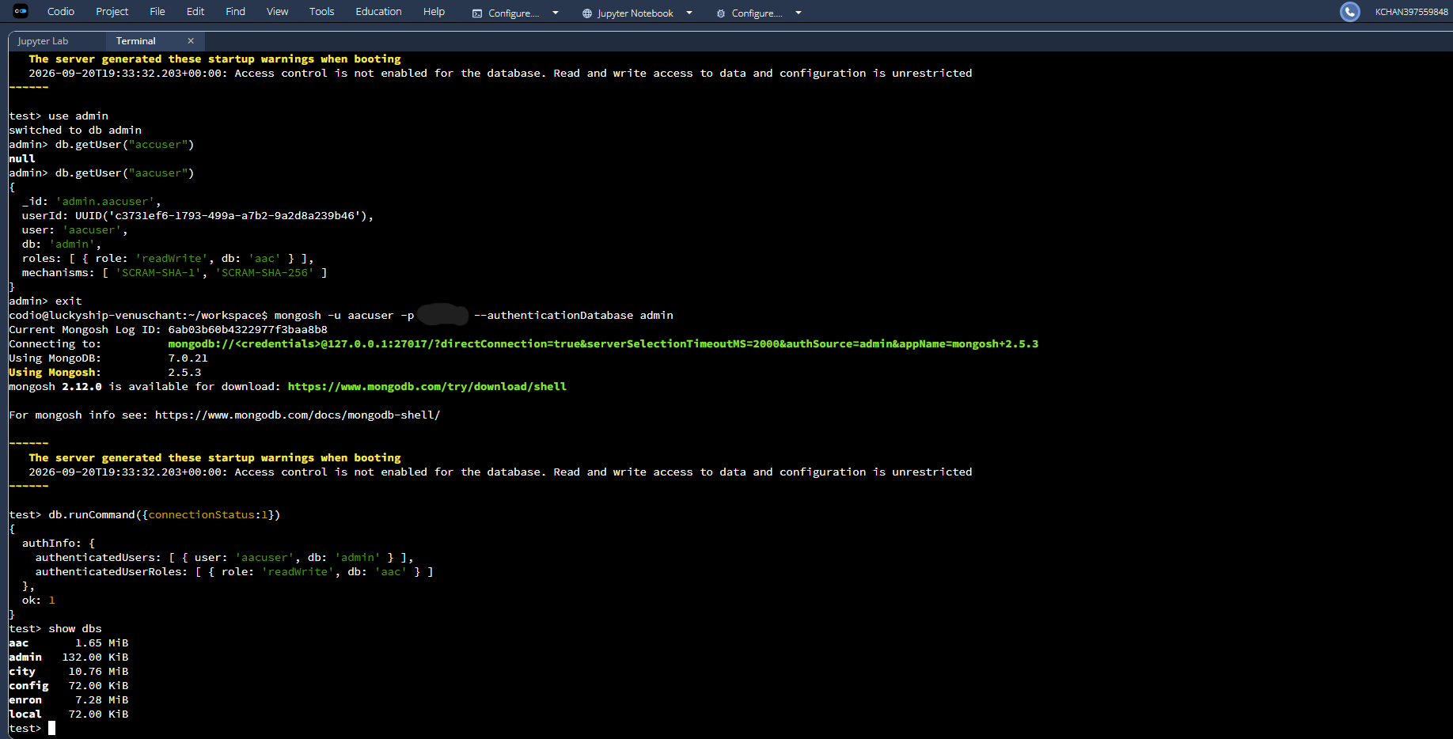
CRUD Functionality Test Execution
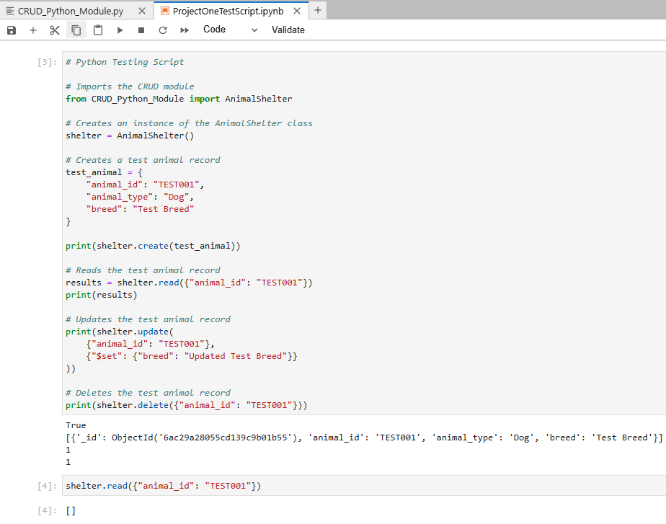
Dashboard
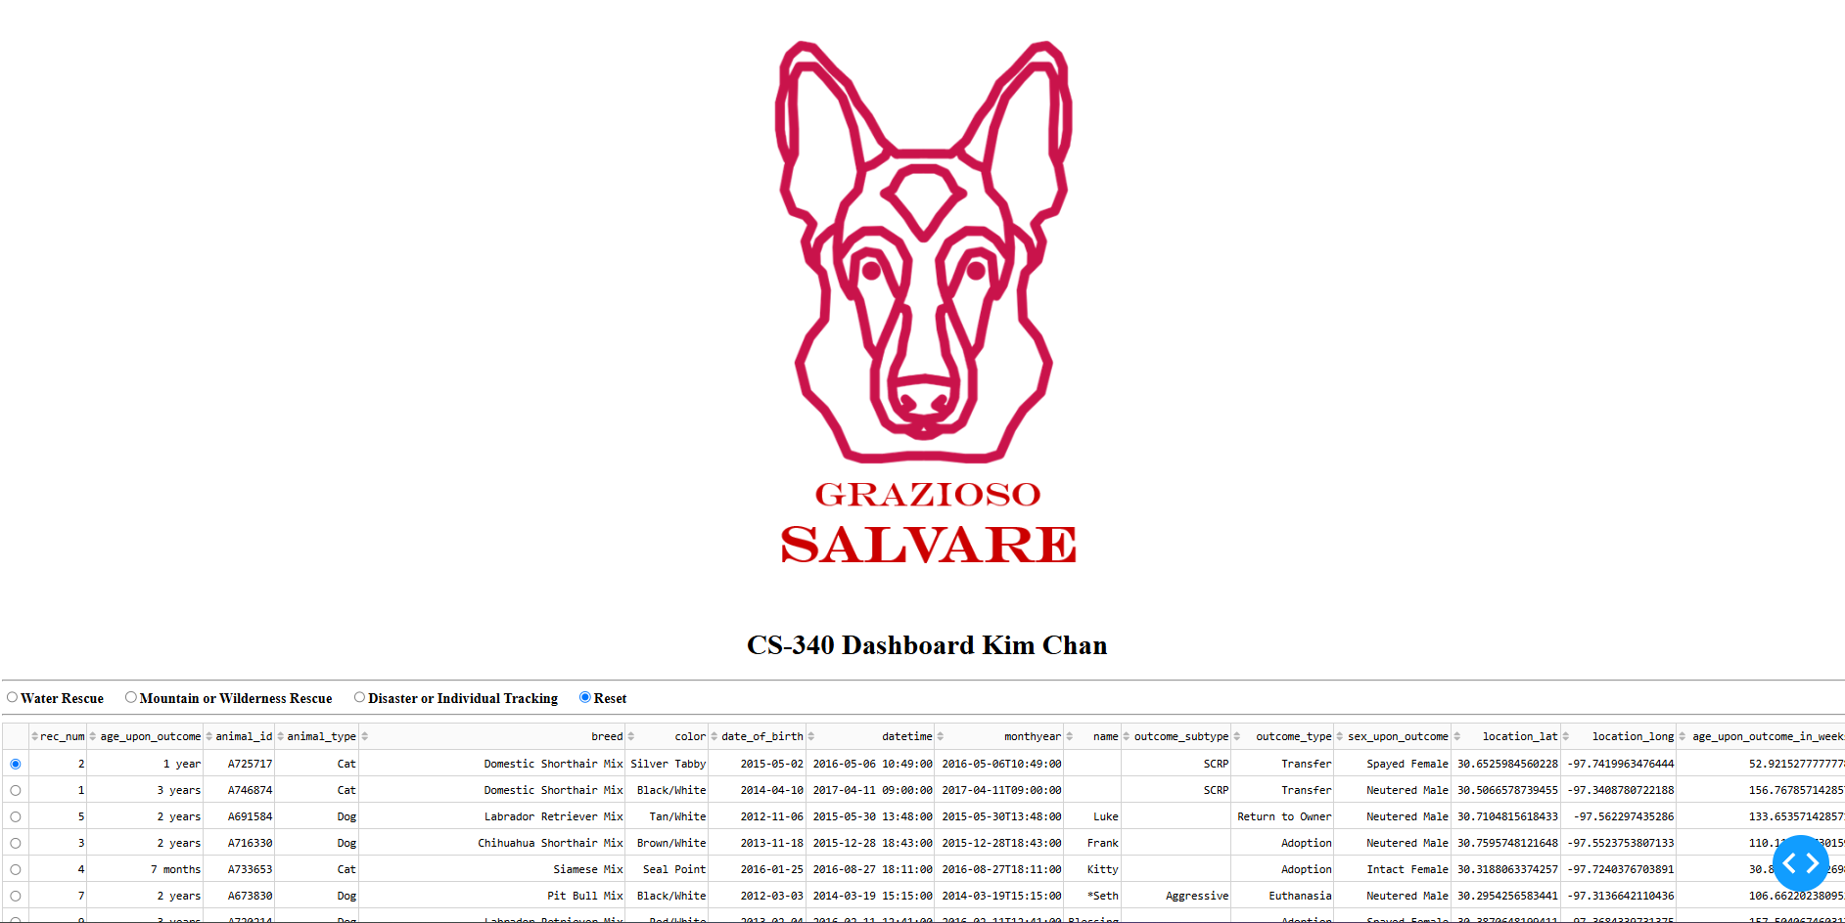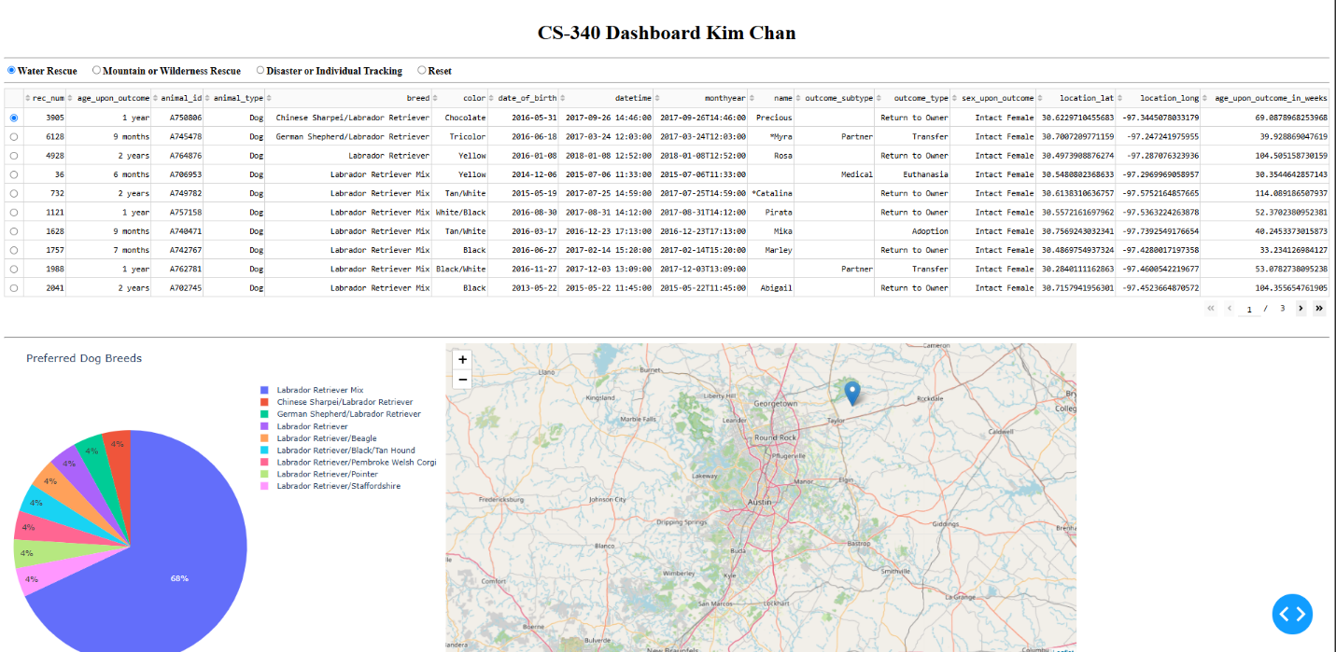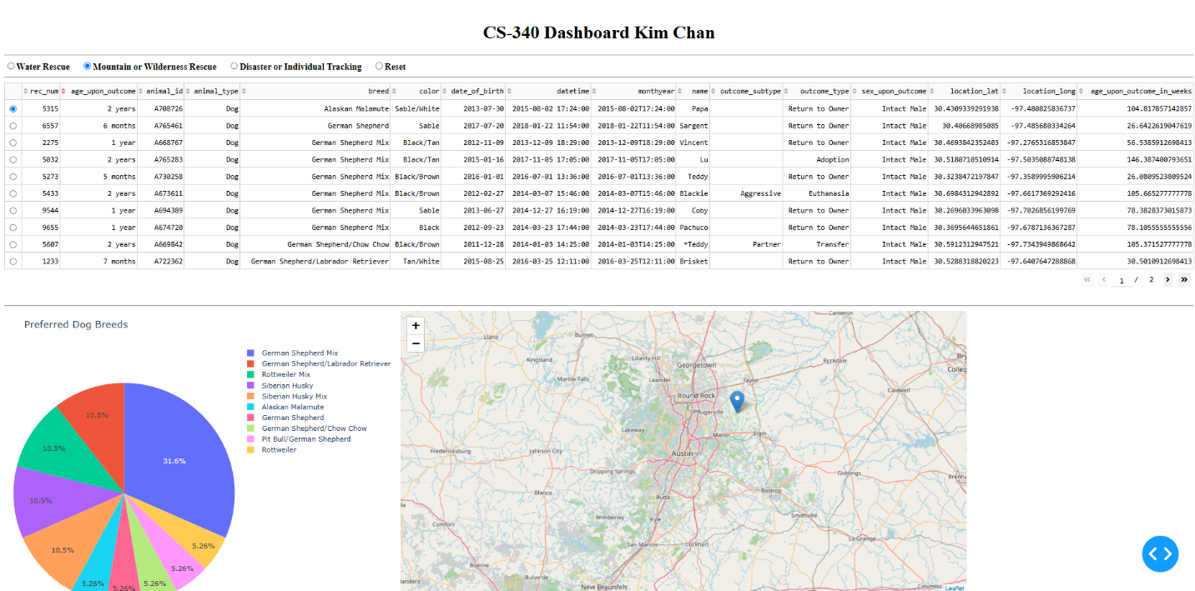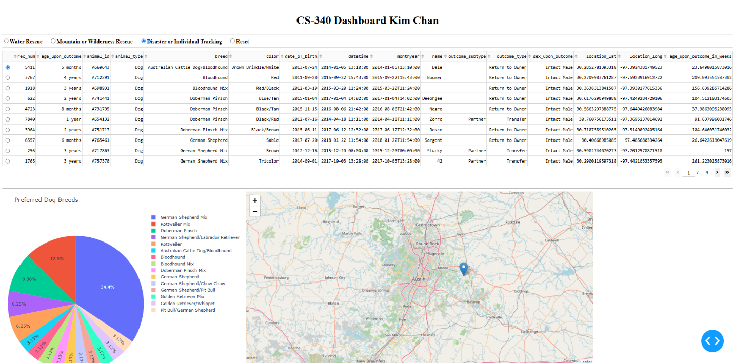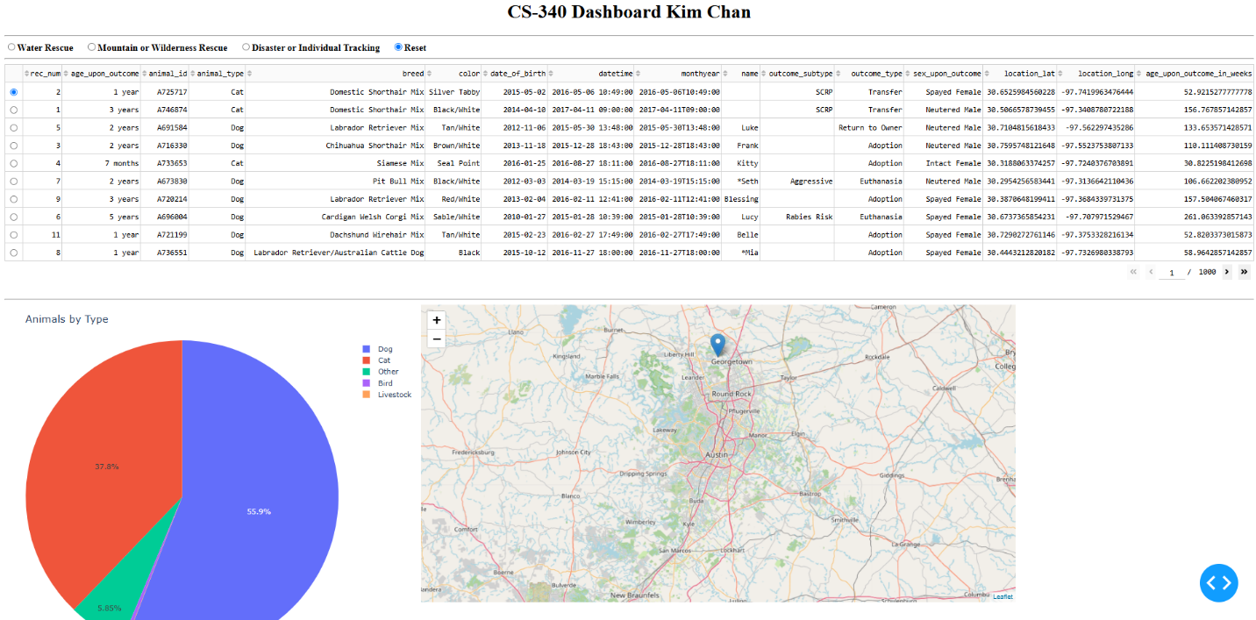
Roadmap
The next step for this project is to use the CRUD Python module developed in Project One as part of the dashboard for Project Two. The dashboard will use MongoDB as the model and the Dash framework to create the view and controller components. The completed application will allow Grazioso Salvare users to filter animal shelter records, view the results in an interactive data table, and use charts to help identify dogs that may be suitable for different types of search-and-rescue training.
Contact
Kim Chan

